14.36: Using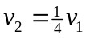in Eq. (14.17),

